

# SINGULAR NOUNS

Known as *possessive -‘s*, *genitive -‘s* or *Saxon genitive*. We use it to show that something belongs to somebody. Read about the different uses in the boxes and do the

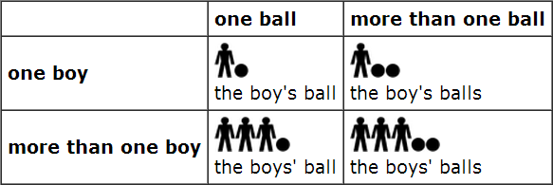

We add **-‘s** to a singular noun: *the boy’s ball the girl’s father the pupil’s*

# PLURAL NOUNS

We add an apostrophe (**‘**) to a plural noun:

*the boys’ ball the girls’ father the pupils’*

# PROPER NOUNS (NAMES)

Both uses in the examples are allowed: *Chris’ dog* and/or *Chris’s dog*

*Doris’ cat* and/or *Doris’s*

# IRREGULAR NOUNS

*the child’s / children’s dog*

*the mouse’s / mice’s food*

*the man’s / men’s car*

**-‘s** vs **of**

We can use ***of*** instead of

**-*‘s***, but ***-‘s*** is more usual and natural:

*the mother of my son my son’s mother*

Notice that the number of balls does not matter.

The structure is influenced by the possessor and not the possessed. *(www.englishclub.com)*

**Rewrite these using the genitive case**

The father of my daughter. The owner of the car.

He is the boss of my wife.

They are the children of my uncle. The car belongs to my sister.

The phone belongs to Louis.

____________________________________________________________

CAMILO DEL VALLE

21/09/22

Answers

1. The father’s daughter
2. The owner’s car
3. My wife’s boss.
4. They are my uncle children’s
5. My sister’s car.
6. The Louis’ phone.